Name

Mathematics Stage 5 Path
Linear Inequalities in
Two Variables

Book 1 | Graph regions corresponding to linear inequalities in one and 2 variables | Version: 260517  Feedback:  https://MrDingMaths.com
Contents
Syllabus Content 2
Linear Inequality Graphs 3

Syllabus Content
MA5-FNC-P-01 uses function notation to describe and graph functions of one variable and graphs inequalities in one and 2 variables
Graph regions corresponding to linear inequalities in one and 2 variables
- Graph linear inequalities of the form $ax+by>c$, testing whether the points satisfy the given inequality and shading appropriate regions

Linear Inequality Graphs

- Review
- Sketch linear functions
- $x=3$ | - $y=-2$ | - $x=-1$
- $y=2x+1$ | - $y=3x-1$ | - $y=4-2x$
- Sketch linear inequalities on a number line
- $x<3$ | - $x≥5$ | - $x<-1$
- $x≥-7$ | - $x>-2$ | - $x≤4$

- Interpret Linear inequalities
Solve $2x-3≥0$.

This tells us that any value of $x$ that is …………… than ……… will satisfy the inequality.
We can graph this on a number line; we can also graph this on a Cartesian plane.
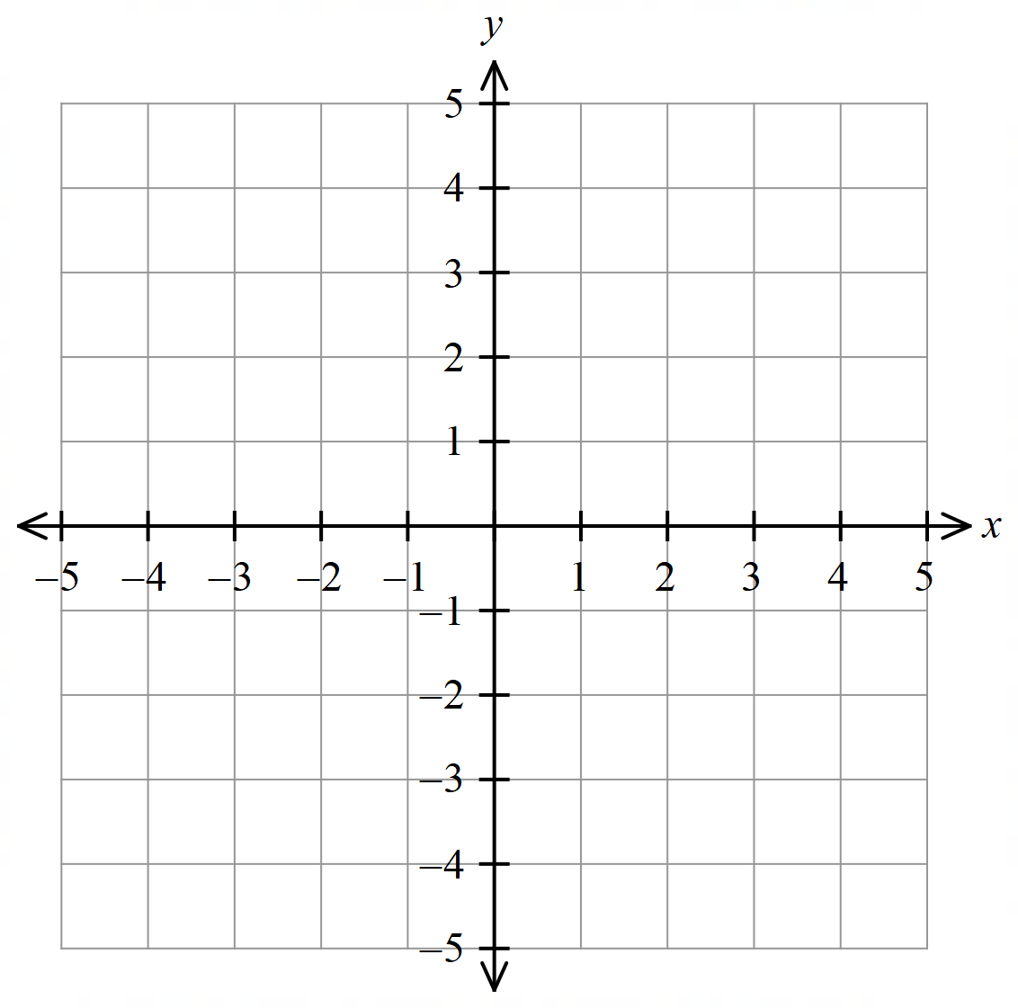

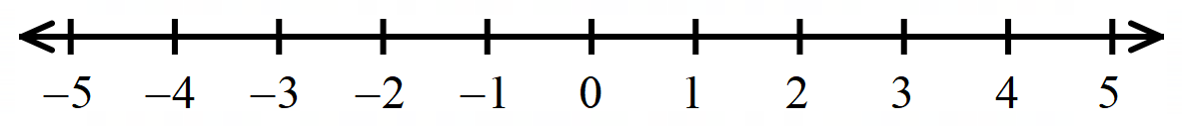

Now consider $y≥2x-3$
We want pairs of values $\left(x,y\right)$ that satisfy this relationship.
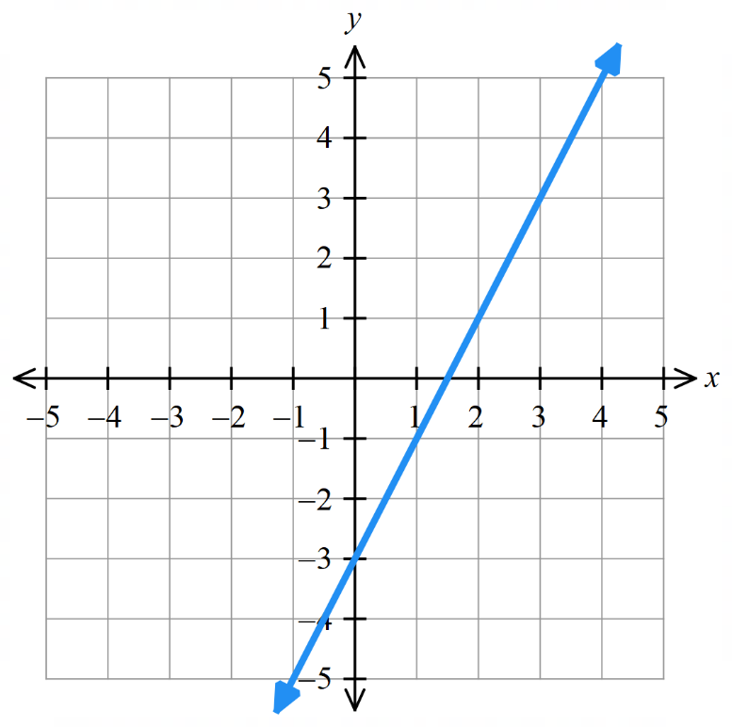
Test these ordered pairs:
$$(1, 3)$$

$$(-4, 4)$$

$$(5,0)$$

$$(1, -2)$$

What points satisfy the relationship?

All the points …… or ……………… the line will satisfy the relationship.

- Sketch Linear Inequalities in Two Variables
            - Rearrange to $y=mx+c$ form.
            - Sketch the line, dotted $(> <)$ or solid ($≥ ≤$), with the intercepts.
- Shade above or below the line, following the question instructions.
$y≥mx+c$, required region is above the line. $y≤mx+c$, required region below the line.
- A question can ask you to indicate a region by shading the required or unwanted region.

- Example Show a region defined by an inequality
Show the region defined by the inequality $3x+4y>24$ by shading the required region.
1. Rearrange  $$4y>-3x+24$$  $$y>-\frac{3x}{4}+6$$ | 2. Sketch dotted line | 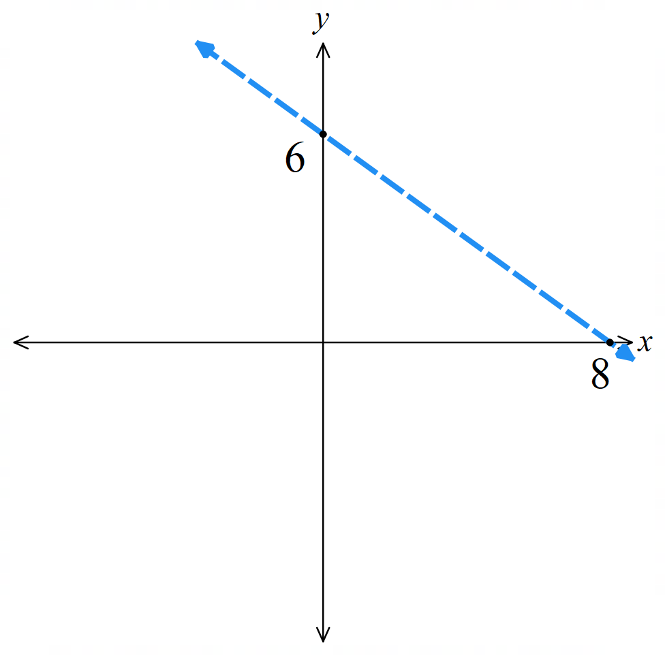  3. Shade required region  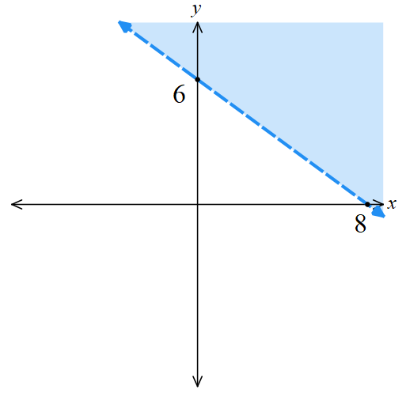

- Guided Practice
Shade the region defined by the inequality by shading the required region.
- $3x-4y>12$ | - $7x-3y≥21$

- Sketch Multiple Linear Inequalities in Two Variables
- These questions will usually ask you to shade the unwanted region.
- Sketch each line and shade the unwanted region.
- The required region will be the region with no shading.
- If you must shade the required region, then use different colours/strokes and see which region has all the overlap.

- Example Show a region defined by two or more inequalities
Show the region defined by $x>-2$ and $y≤3$ by shading the unwanted regions.
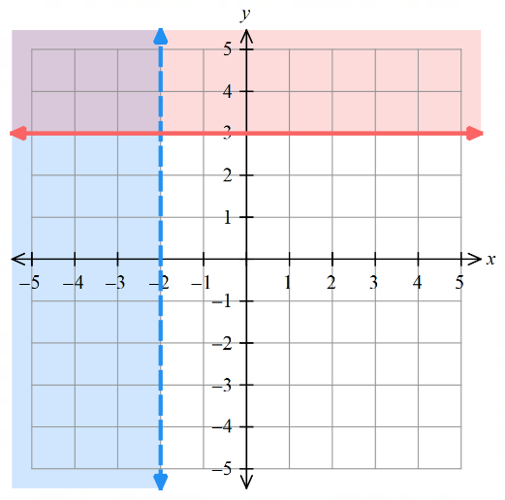
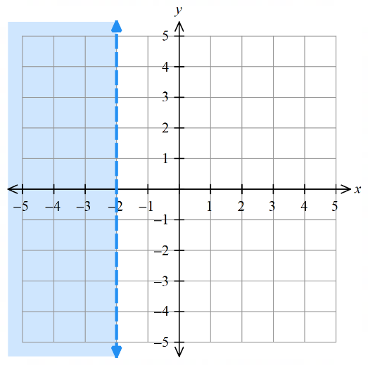
1. Sketch each line and shade unwanted 2. Required region is unshaded
R

Alternate method, find required region by considering the most overlap
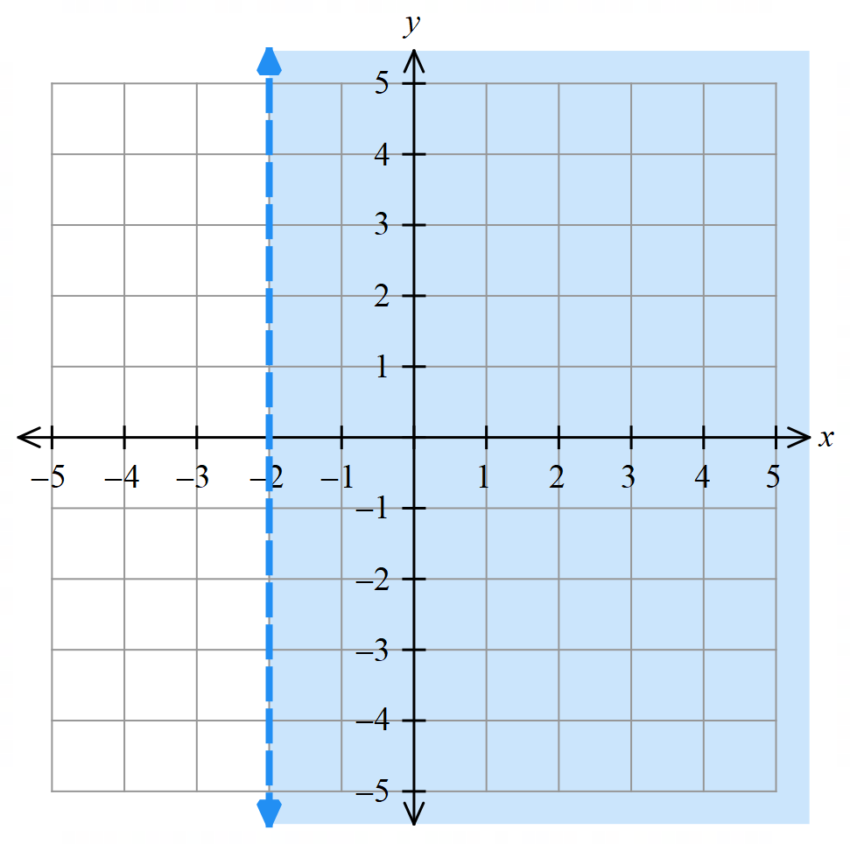
1. Sketch each line and shade required 2. Required region has most overlap
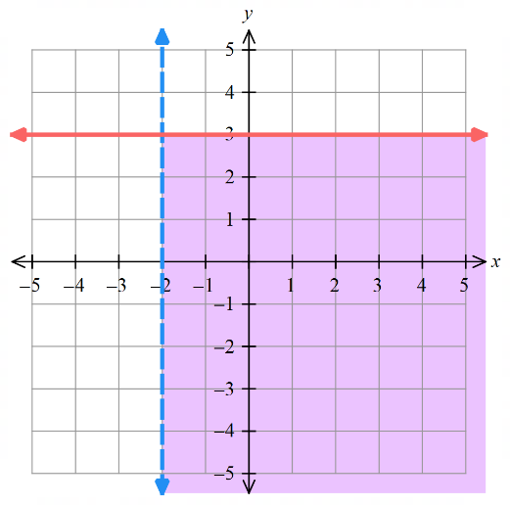
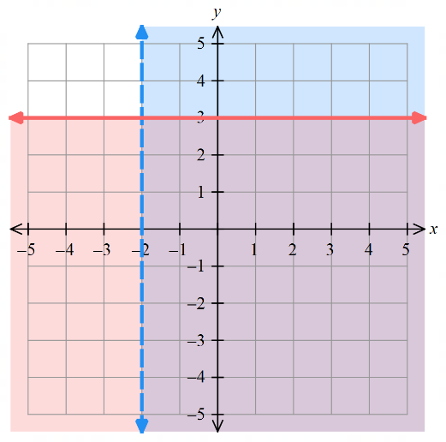
R

- Guided Practice
Show the required region by shading the unwanted regions.
$$x>-2$$  $$y≤-1$$ | 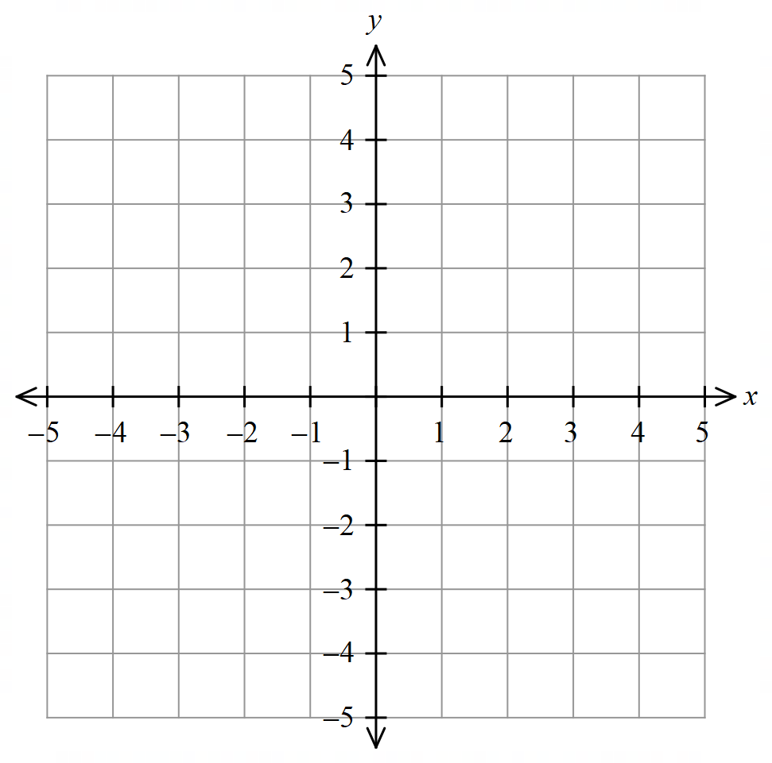  $$y≥2x-1$$  $$y<3-x$$

Foundation
- Sketch the region for the following linear inequalities. Show the $x$ and $y$ intercepts.
- $y ≥ x + 4$  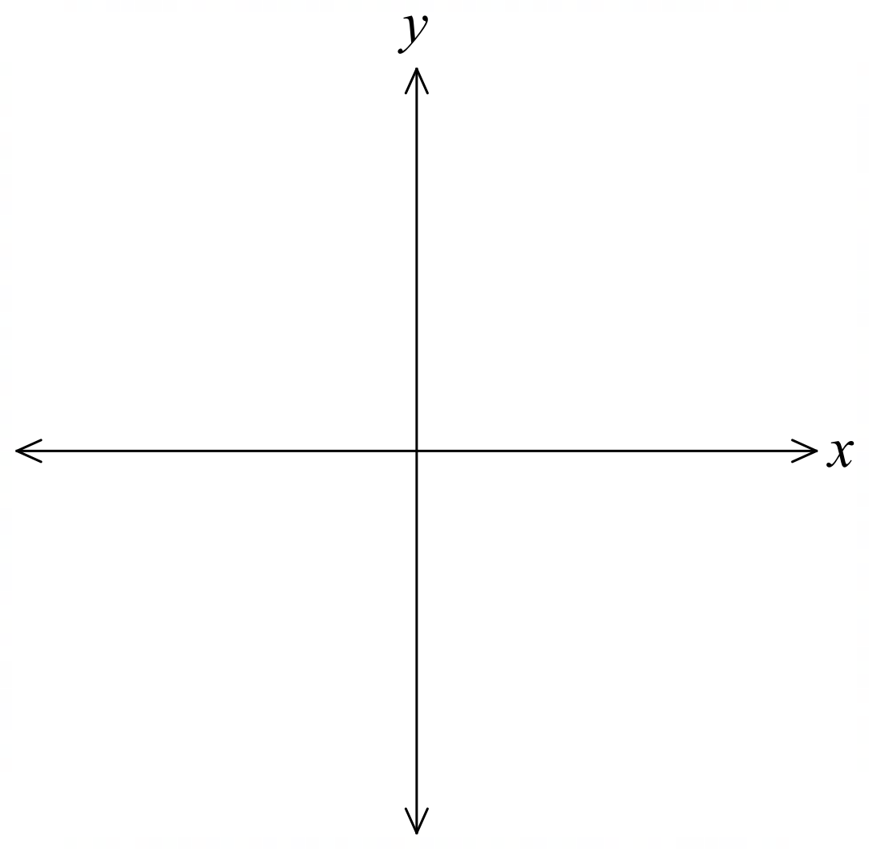  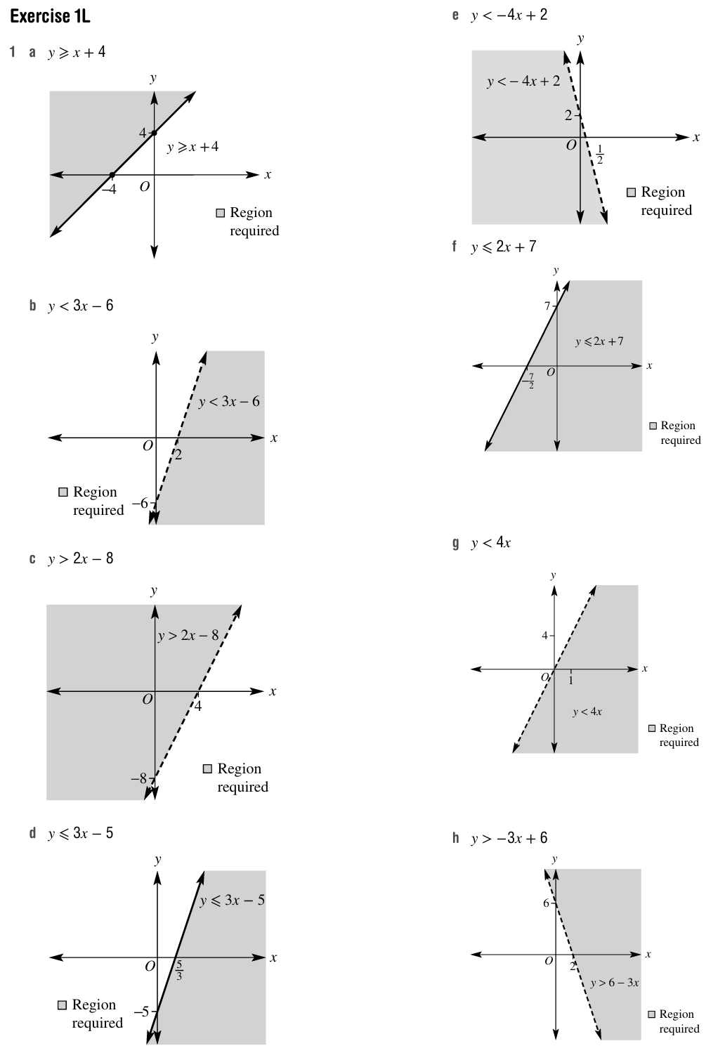 | - $y < 3x - 6$ | - $y > 2x - 8$
- $y ≤ 3x - 5$ | - $y < 2 - 4x$ | - $y ≤ 2x + 7$
- $y < 4x$ | - $y > 6 - 3x$ | - $y ≤ -x$  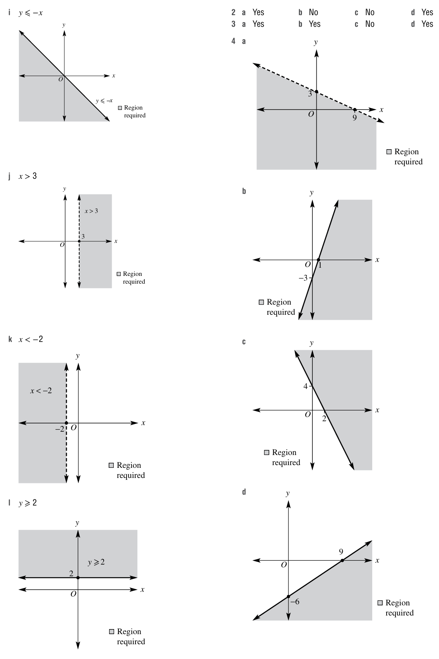
- $x > 3$ | - $x < -2$ | - $y ≥ 2$
- Decide, by substitution, whether the following points are in the region defined by $2x - 3y > 8.$
- $(5, 0)$  $$2\left(5\right)-3\left(0\right)=10>8$$  yes | - $(2.5, -1)$  no | - $(0, -1)$  no | - $(2, -5)$  yes

- Decide if $(0, 0)$ lies in the region defined by the following.
- $x + y < 4$  yes | - $x - 2y > -2$  yes | - $3x - 2y < -4$  no | - $x - 5y < 2$  yes

- State the inequalities which define each shaded region.
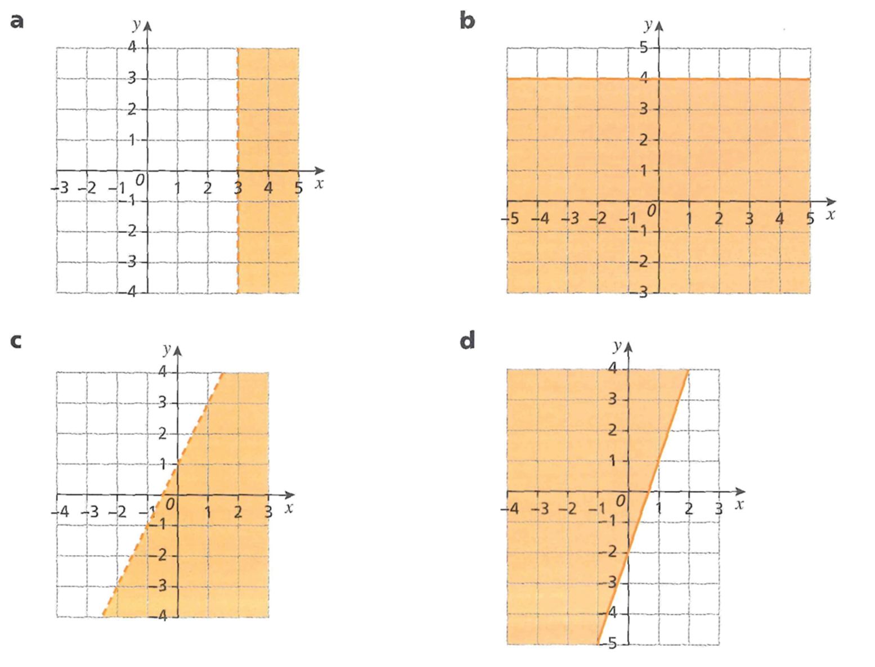  $$x>3$$ | $$y≤4$$
$$y<2x+1$$ | $$y≥3x-2$$

Development
- Sketch the region for the following linear inequalities.
- $x + 3y < 9$ | - $3x - y ≥ 3$ | - $4x + 2y ≥ 8$
- $2x - 3y≥ 18$ | - $-2x + y ≤ 5$  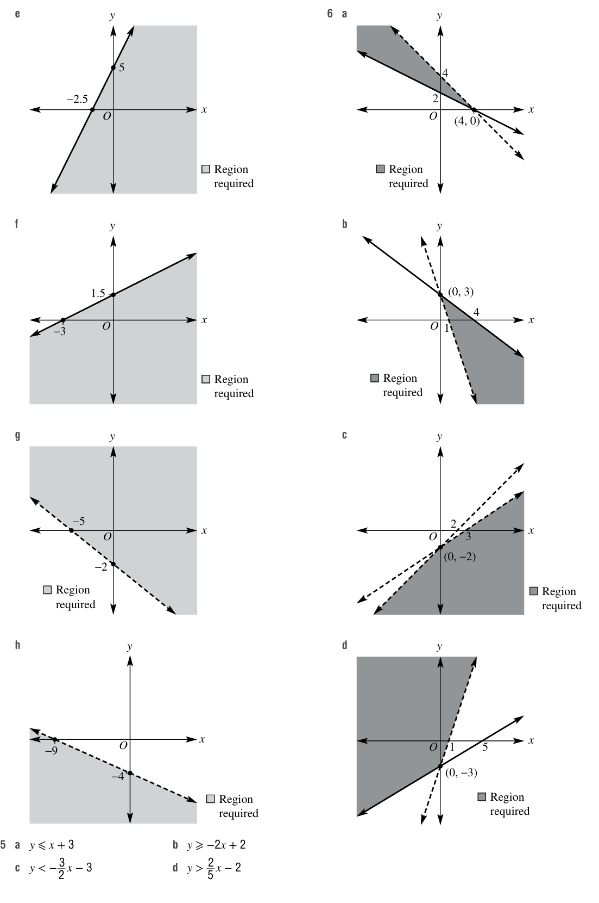 | - $-2x + 4y ≤ 6$

- Write down the inequalities that give these regions.
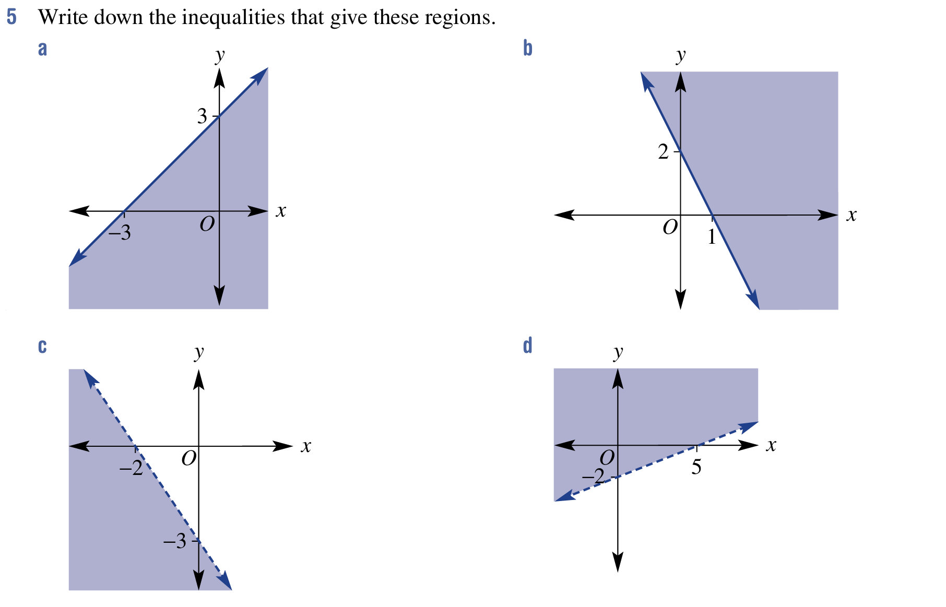  $$y≤x+3$$ | $$y≥-2x-2$$
$$y<-\frac{3}{2}x-3$$ | $$y>\frac{2}{5}x-2$$
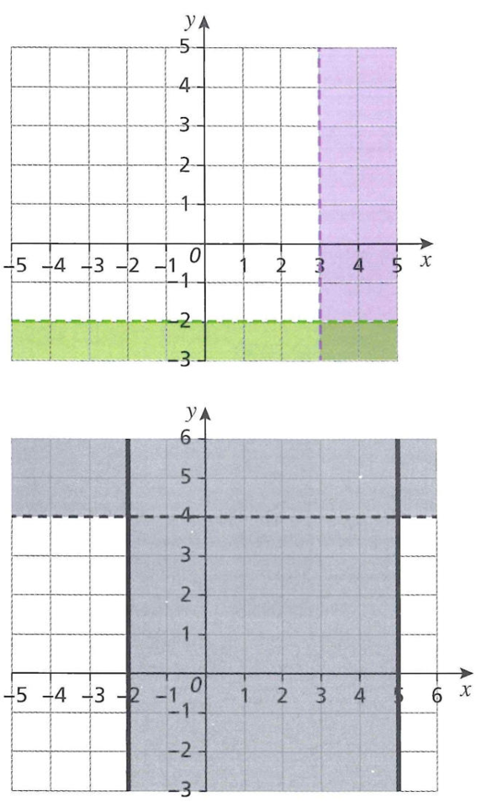
- On the set of coordinate axes, identify the region(s) defined by each set of inequalities.
In each case, shade the unwanted region.
- $x < 3$ and $y > -2$  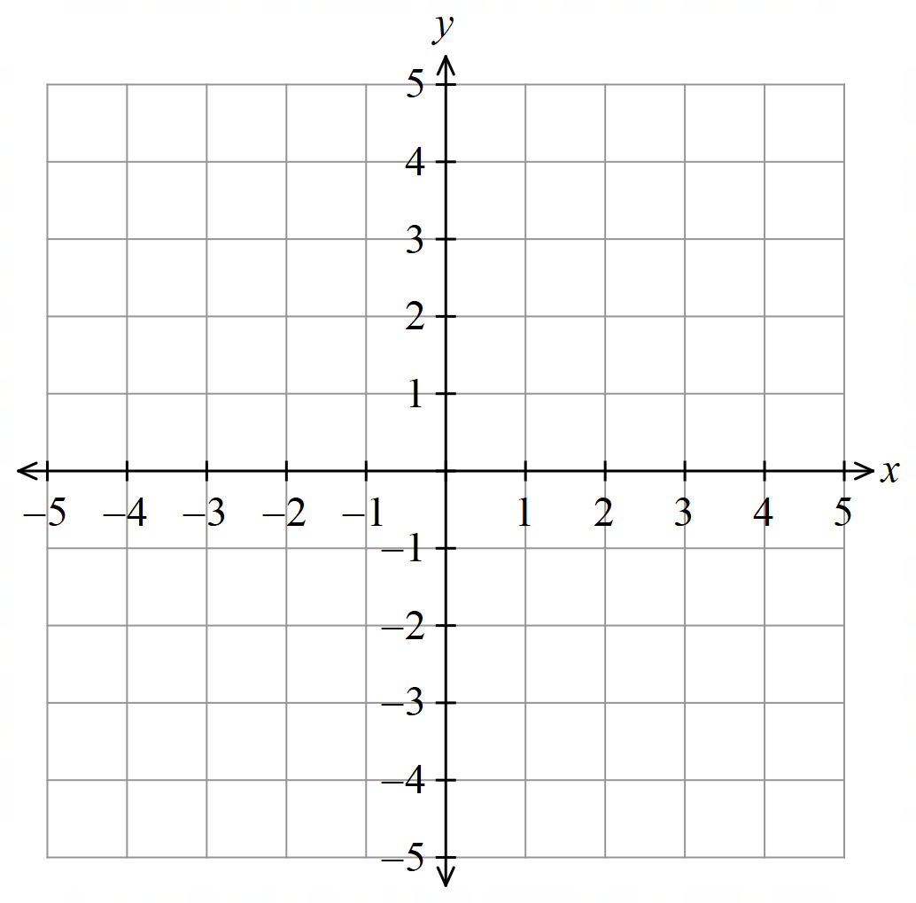 | - $x ≤ -2, x ≥ 5$ and $y < 4$
- $-3 < x < 1$ and $y > 2$  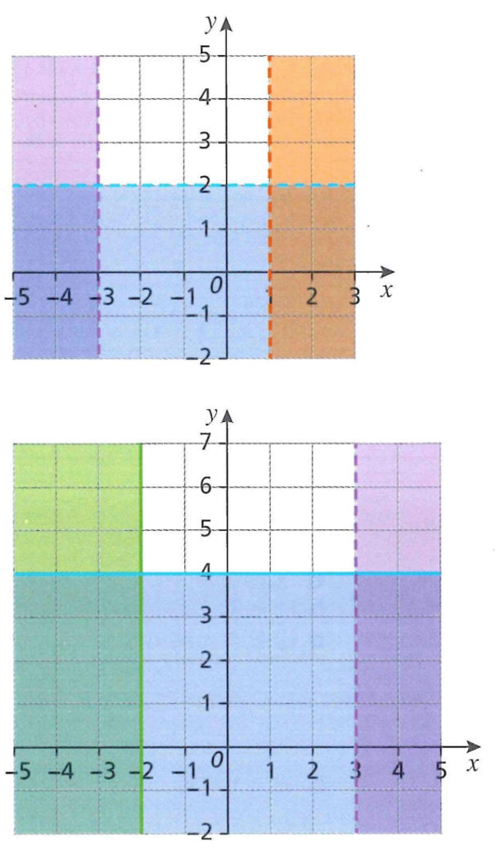 | - $y ≥ 4$ and $-2 ≤ x < 3$

- State the sets of inequalities which define each unshaded region.
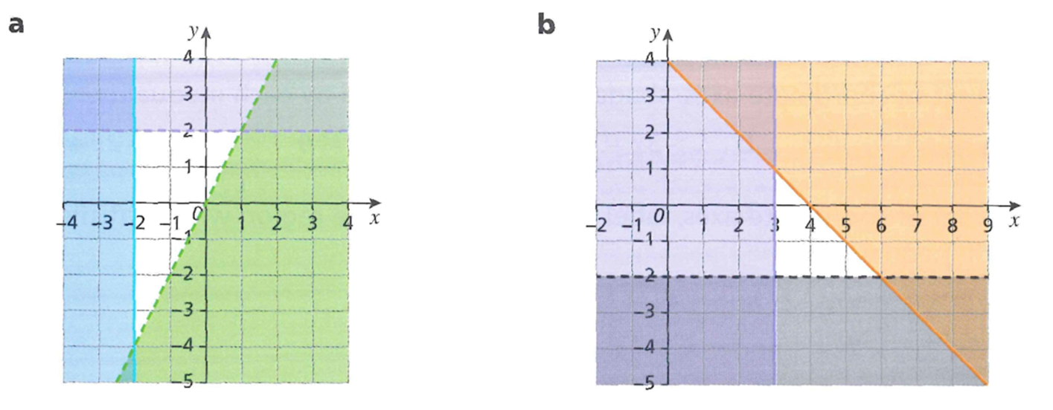  $$y<2$$  $$x≥2$$  $$y>2x$$ | $$x≥3$$  $$y>-2$$  $$y≤4-x$$

- Sketch both inequalities on the same set of axes, shade the region of intersection and find the point of intersection of the two lines.
- $x + 2y ≥ 4$ and $2x + 2y < 8$ | - $3x + 4y ≤ 12$ and $3x + y > 3$
- $2x - 3y > 6$ and $y < x - 2$ | - $3x - 5y ≤ 15$ and $y - 3x > -3$
- $y ≥ -x + 4$ and $2x + 3y ≥ 6$  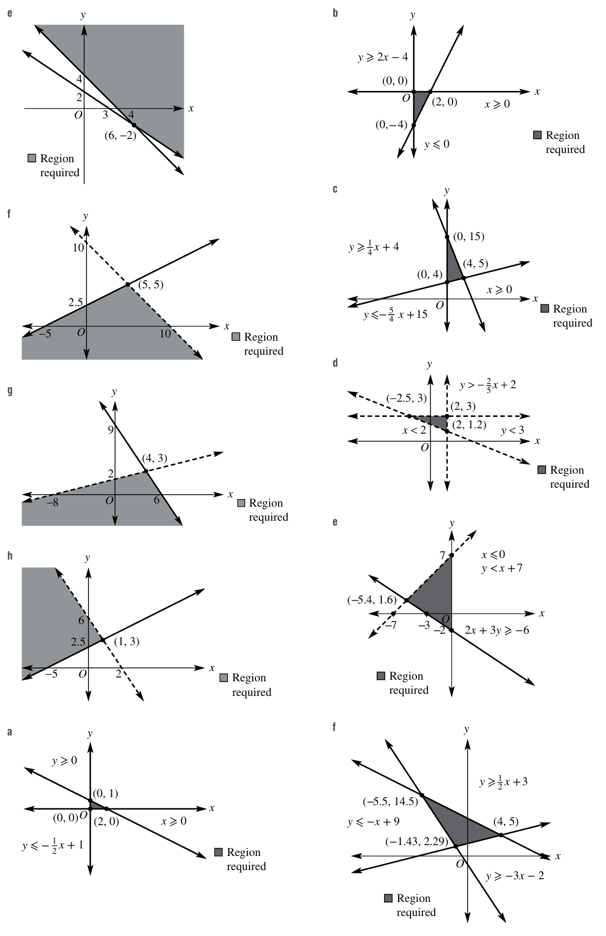 | - $2y - x ≤ 5$ and $y < 10 - x$

- On a set of coordinate axes, label with the letter $R$ the region which satisfies the given set of inequalities.
- $y ≥ x + 1, y ≤ -2x$  $$x ≥ -1$$  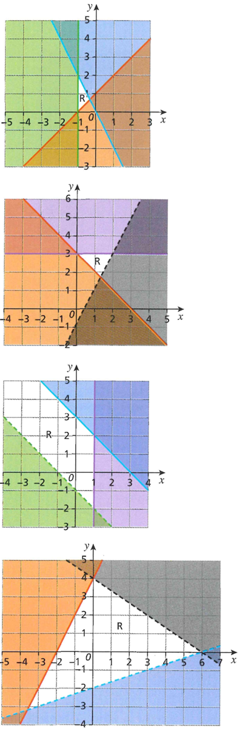 | - $y ≤ 3,$$$y > 2x - 1$$$y ≥ 3 - x$
- $y + x ≤ 3, y > -x - 1$  $x ≤ 1$ | - $3y+2x<12, y - 2x ≤ 4$  $$x - 3y < 6$$

- Determine the original inequalities that would give the following regions of intersection.
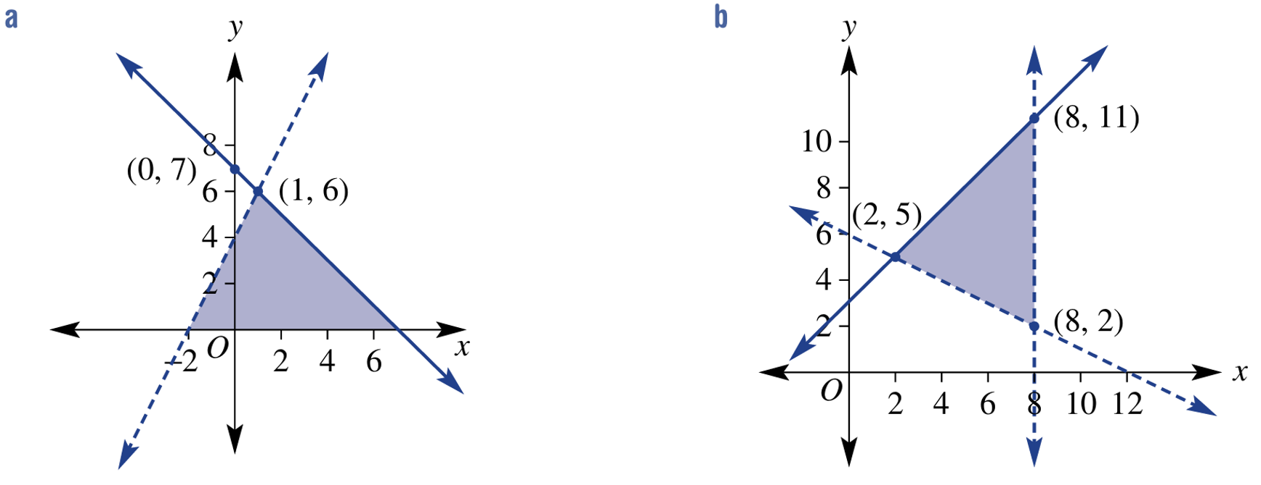  $$y≥0$$  $$y<2x+4$$  $$y≤-x+7$$ | $$y>-\frac{1}{2}x+6$$  $$y≤x+3$$  $$x<8$$

Mastery
- Sketch the following systems of inequalities on the same axes. Show the intersecting region and label the points of intersection. The result should be a triangle in each case.
- $x ≥ 0,$$$y ≥ 0,$$$3x + 6y ≤ 6$ | - $x ≥ 0,$$$y ≤ 0,$$$2x - y ≤ 4$
- $x ≥ 0,$$$5x + 2y ≤ 30,$$$4y - x ≥ 16$ | - $x < 2,$$$y < 3,$$$2x + 5y > 10$

- $x$and $y$ satisfy the inequalities $y<2x+1, 3y+2x≤12$ and $y>1$.
  - On a set of coordinate axes, show the region satisfied by the inequalities and shade the unwanted region.
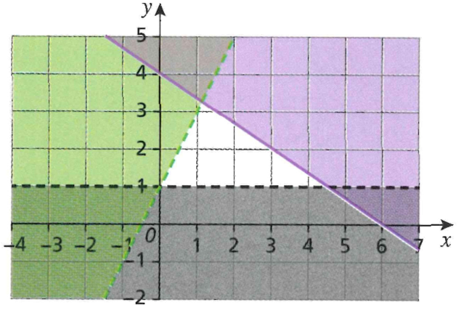
  - Given that $x$ and $y$ are both integers, state the possible values of $x$ and $y$.

$$\left(1,2\right) \left(3,2\right) \left(2,2\right)$$

- State the sets of inequalities which define the unshaded region.
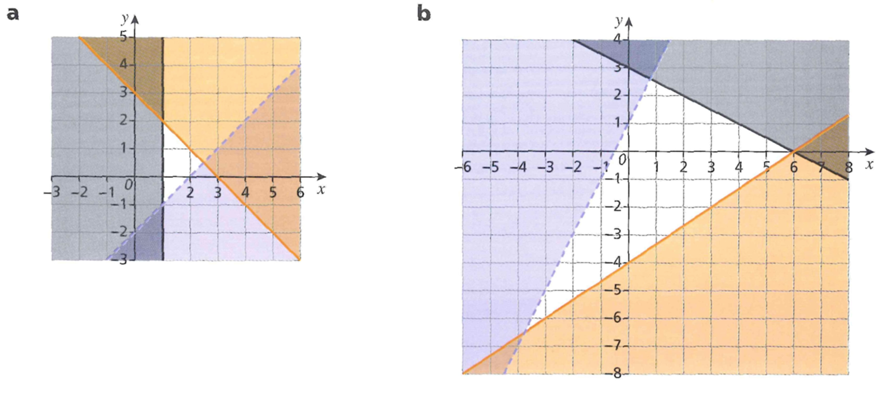  $$y>x-2$$  $$x≥1$$  $$y≤3-x$$ | $$y<2x+1$$  $$y≤-\frac{x}{2}+3$$  $$y≥\frac{2}{3}x-4$$
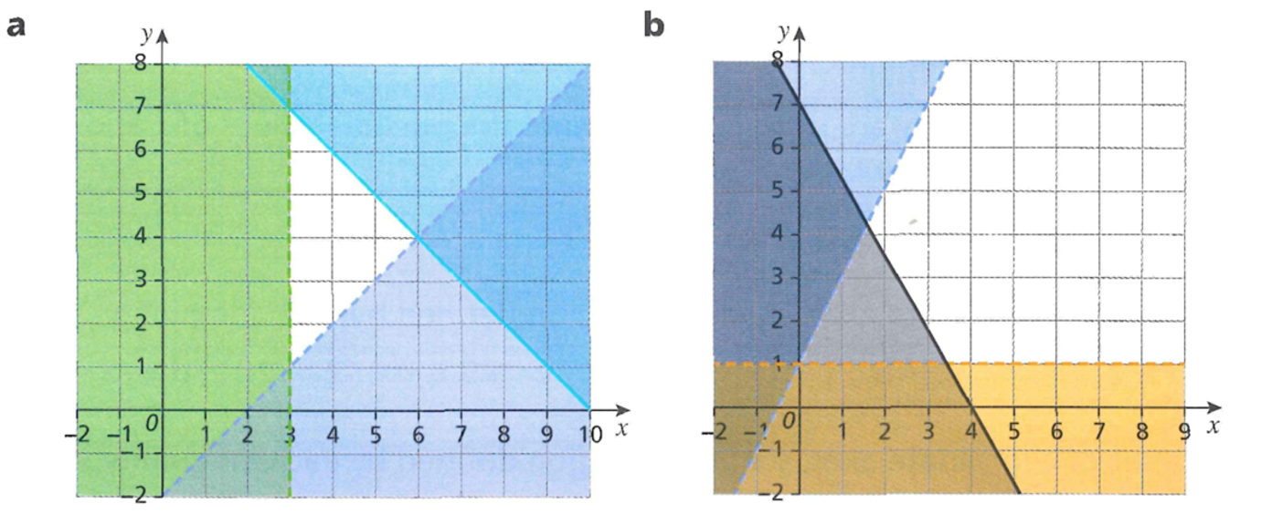  $$y>x-2$$  $$x+y≤10$$  $$x>3$$ | $$y<2x+1$$  $$y>1$$  $$7x+4y≥28$$
- Benji wants to buy some chocolate bars. He decides to buy $x$ wafer bars and $y$ caramel bars.
- He wants at least two caramel bars.
- He wants at least one wafer bar.
- His mum says he can have no more than 5 bars altogether.
Illustrate the problem above using inequalities on a graph and list the different ways he can buy the chocolate bars.
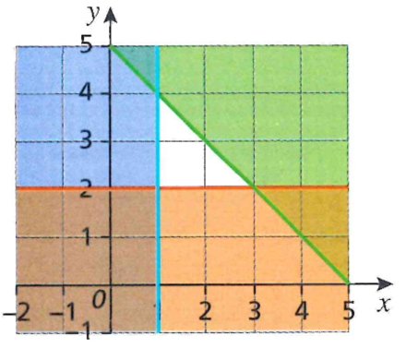
By looking at the integer points that lie in the acceptable region:
1 wafer, 2 caramel
1 wafer, 3 caramel
1 wafer, 4 caramel
2 wafer, 2 caramel
2 wafer, 3 caramel
3 wafer, 2 caramel

- At a theme park, one ride on the water slide costs £4 and one ride on the Ferris wheel costs £3. Flo has £20 to spend. She has $W$ rides on the water slide and $F$ rides on the Ferris wheel.
  - Explain why the following inequalities hold.
    - $W ≥ 0$ and $W ≤ 5$
    - $F ≥ 0$ and $F ≤ 6$
    - $4W + 3F ≤ 20$

i) The number of rides on the water slide has to be positive and cannot be more than 5, as 5 rides would cost £20
ii) The number of rides on the Ferris wheel would have to be positive and cannot be more than 6, as 7 rides would cost £21
iii) The total cost of water slide rides would be 4W, the total cost of Ferris wheel rides would be 3F.
The sum of these must be less than or equal to the £20 that Flo has.
  - Show the region satisfied by the inequalities on a graph, using the $x$-axis for $W$ and
the $y$-axis for $F$. Shade the unwanted region.
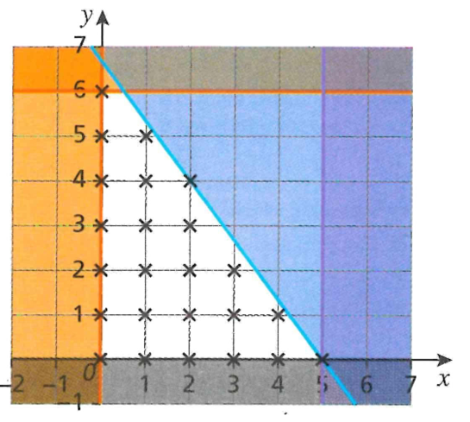

  - On your graph above, mark with a cross ($X$) all possible combinations of rides that satisfy the inequalities.
  - Which combination gives a mixture of both rides and means Flo spends the whole £20?
To spend the whole £20, the point needs to lie on the line $4W+3F=20$
The only point satisfying the region and lying on the line is (2,4)
2 water slide rides and 4 Ferris wheel rides

